EXPERIMENT NO. 06

Visualize Datasets Using Bar Chart, Histogram, Pie Chart, and Boxplot

PART B

TO BE COMPLETED BY STUDENTS
Roll No. 60 | Name: Avdhut Parish Madhavi
Class: S.E. - C | Batch: C2
Date of Experiment: | Date of Submission
Grade:

B.1 Program Code
#--------------------------------------------------
# EXPERIMENT NO. 06
# VISUALIZATION USING BAR CHART, HISTOGRAM,
# PIE CHART AND BOXPLOT
#--------------------------------------------------

# Install ggplot2 if required
# install.packages("ggplot2")

# Load library
library(ggplot2)

#--------------------------------------------------
# CREATE AGRICULTURE DATASET
#--------------------------------------------------

agri_data <- data.frame(
Crop = c(
"Rice",
"Wheat",
"Maize",
"Cotton",
"Sugarcane",
"Soybean",
"Groundnut",
"Pulses",
"Jowar",
"Bajra"
),

Production = c(
500,
400,
350,
300,
600,
250,
280,
220,
180,
160
),

Area = c(
100,
80,
70,
90,
120,
75,
70,
60,
50,
45
),

Yield = c(
5.0,
5.0,
5.0,
3.3,
5.0,
3.3,
4.0,
3.7,
3.6,
3.6
)
)

# Display dataset
print(agri_data)

# Display first observations
head(agri_data)

# Display summary
summary(agri_data)

#--------------------------------------------------
# 1. BAR CHART
# Crop-wise Production
#--------------------------------------------------

ggplot(
agri_data,
aes(x = Crop, y = Production)
) +
geom_col() +
labs(
title = "Crop-wise Agricultural Production",
x = "Crop",
y = "Production"
) +
theme_minimal()

#--------------------------------------------------
# 2. HISTOGRAM
# Distribution of Production
#--------------------------------------------------

ggplot(
agri_data,
aes(x = Production)
) +
geom_histogram(
bins = 5
) +
labs(
title = "Distribution of Agricultural Production",
x = "Production",
y = "Frequency"
) +
theme_minimal()

#--------------------------------------------------
# 3. PIE CHART
# Crop-wise Share of Production
#--------------------------------------------------

ggplot(
agri_data,
aes(
x = "",
y = Production,
fill = Crop
)
) +
geom_col() +
coord_polar("y") +
labs(
title = "Crop-wise Share of Total Production"
) +
theme_void()

#--------------------------------------------------
# 4. BOXPLOT
# Distribution of Production
#--------------------------------------------------

ggplot(
agri_data,
aes(
x = "Agricultural Crops",
y = Production
)
) +
geom_boxplot() +
labs(
title = "Boxplot of Agricultural Production",
x = "",
y = "Production"
) +
theme_minimal()

#--------------------------------------------------
# 5. BOXPLOT
# Yield Distribution
#--------------------------------------------------

ggplot(
agri_data,
aes(
x = "Agricultural Crops",
y = Yield
)
) +
geom_boxplot() +
labs(
title = "Boxplot of Crop Yield",
x = "",
y = "Yield"
) +
theme_minimal()

B.2 Expected Output
The program generates the following visualizations.

Output 1: Bar Chart
Title: Crop-wise Agricultural Production
The bar chart displays production values for different crops.

Interpretation
The graph makes it easy to compare production among different crops. In the given sample data, sugarcane has the highest production value, while bajra has the lowest.
Input:-
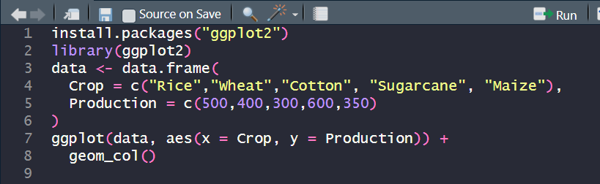

Output:-
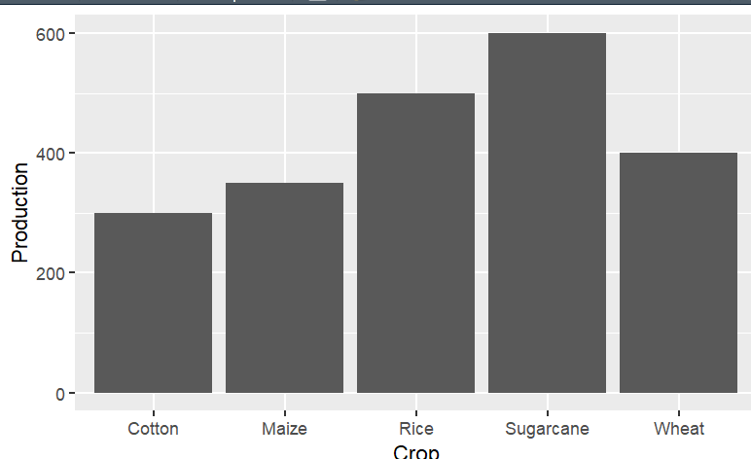

Output 2: Histogram
Title: Distribution of Agricultural Production
The histogram represents the frequency distribution of production values.

Interpretation
The histogram helps understand how the production observations are distributed across different ranges.
Input:-
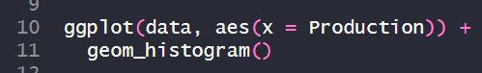
Output:-
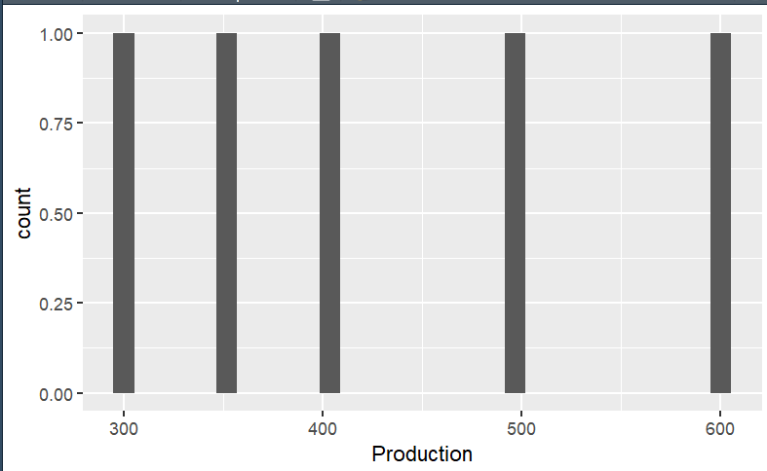

Output 3: Pie Chart
Title: Crop-wise Share of Total Production
The pie chart represents the contribution of each crop to the total production.

Interpretation
Each slice represents the proportion of total production contributed by a particular crop.

Input:-
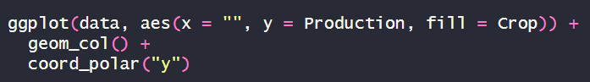
Output:-
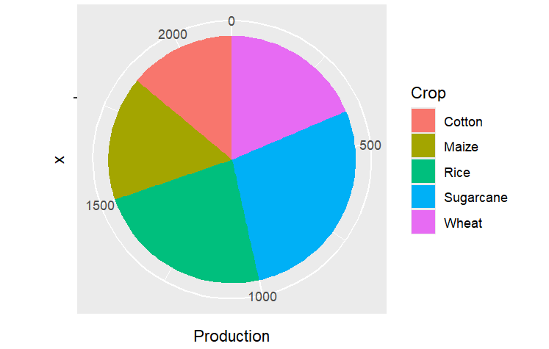

Output 4: Boxplot
Title: Boxplot of Agricultural Production
The boxplot summarizes the distribution of production values.

Interpretation
The boxplot displays the median, quartiles, spread, and possible outliers in the production data.
Input:-
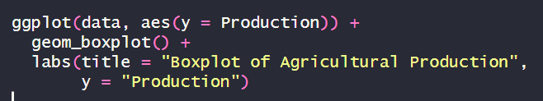
Output:-
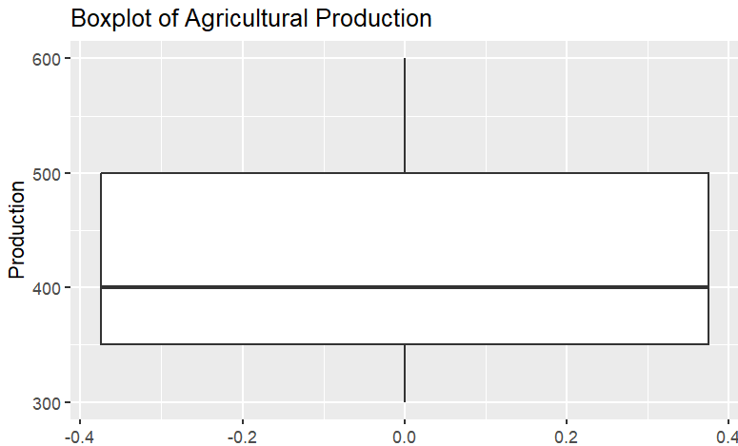

Output 5: Yield Boxplot
Title: Boxplot of Crop Yield
This graph represents the distribution of crop yield.

Interpretation
The boxplot can be used to study the spread and variation in yield values.
Input:-
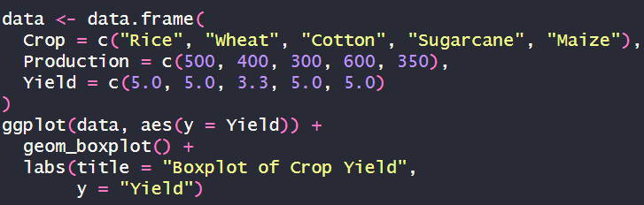
Output:-
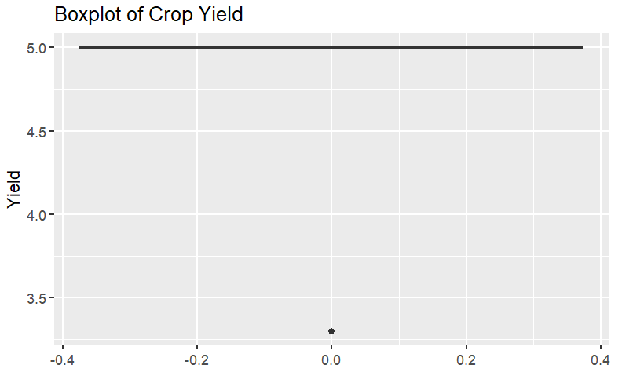

B.3 Observation
Sr. No. | Visualization | Observation
1 | Bar Chart | Crop-wise production was compared successfully.
2 | Histogram | Distribution of agricultural production was visualized.
3 | Pie Chart | Contribution of each crop to total production was represented.
4 | Boxplot | Distribution and spread of production were analyzed.
5 | Yield Boxplot | Variation in crop yield was represented.

B.4 Observation Table
Graph | Variable | Purpose | Result
Bar Chart | Crop & Production | Compare crop production | Successfully visualized
Histogram | Production | Study frequency distribution | Successfully visualized
Pie Chart | Crop & Production | Show production share | Successfully visualized
Boxplot | Production | Study spread and outliers | Successfully visualized
Boxplot | Yield | Study yield variation | Successfully visualized

B.5 Result
The agriculture dataset was successfully visualized in R using bar chart, histogram, pie chart, and boxplot.
The bar chart was used to compare crop-wise production, the histogram was used to understand the distribution of production values, the pie chart represented the contribution of each crop to total production, and the boxplot was used to study the spread and variation of the dataset.
Thus, the experiment demonstrated the practical application of graphical data visualization techniques for statistical data analysis.

B.6 Applications
The visualization techniques used in this experiment can be applied to:
- Agricultural production analysis.
- Crop yield comparison.
- Smart city data analysis.
- Air quality analysis.
- Population analysis.
- Traffic analysis.
- Healthcare data analysis.
- Business and sales analysis.
- Environmental data analysis.
- Financial data analysis.
- Exploratory data analysis.
- Statistical reporting.
- AI and machine learning data analysis.
- Decision-making and planning.
The syllabus identifies data visualization and interpretation of analytical results as an important laboratory outcome.

B.7 Precautions
- Ensure that ggplot2 is installed and loaded correctly.
- Check the dataset before visualization.
- Ensure numerical variables are stored in numeric format.
- Select an appropriate graph according to the type of data.
- Use histograms for numerical distributions.
- Use bar charts for categorical comparisons.
- Use pie charts only when categories represent meaningful parts of a whole.
- Add meaningful titles and axis labels.
- Select a suitable number of histogram bins.
- Check boxplots for possible outliers.
- Verify the generated graph before recording the result.
- Save the R program and screenshots of all outputs.

B.8 Questions of Curiosity



B.9 Viva Voce Questions
- What is R?
- What is RStudio?
- What is ggplot2?
- How do you install ggplot2?
- How do you load ggplot2?
- What is the purpose of ggplot()?
- What is aes()?
- What is a geom?
- Which function is used to create a bar chart?
- Which function is used to create a histogram?
- Which function is used to create a boxplot?
- How is a pie chart created in ggplot2?
- What is coord_polar()?
- What is the difference between geom_bar() and geom_col()?
- What does a histogram show?
- What does a boxplot show?
- What is Q1?
- What is Q3?
- What is IQR?
- What is an outlier?
- Why are graphs useful in statistical analysis?
- Which graph is suitable for comparing categories?
- Which graph is suitable for showing data distribution?
- Which graph can be used to show parts of a whole?
- Which graph is useful for identifying outliers?
- Give two applications of data visualization in agriculture.
- Give two applications of data visualization in smart cities.
- Why should graphs have proper labels?
- What is exploratory data analysis?
- How can visualization help in decision-making?

